**Part4**

1. Write a query to display the last name, department number and department name for all employees.

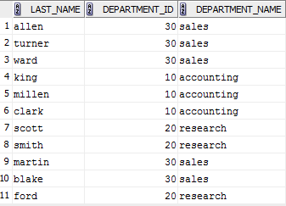

1. Create a unique listing of all jobs that are in department 80. Include the location of department in the output.

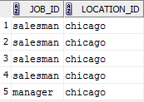

1. Write a query to display the employee last name, department name, location ID, and city of all employees who don’t earn a commission.

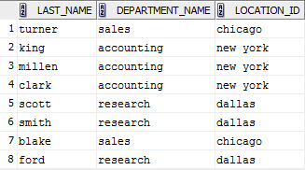

1. Display the employee last name and department name for all employees who have an “a” (lowercase) in their last names.

